# **Deliverables for <TTKI - Tulis Tulis Karya Imajinasi>**

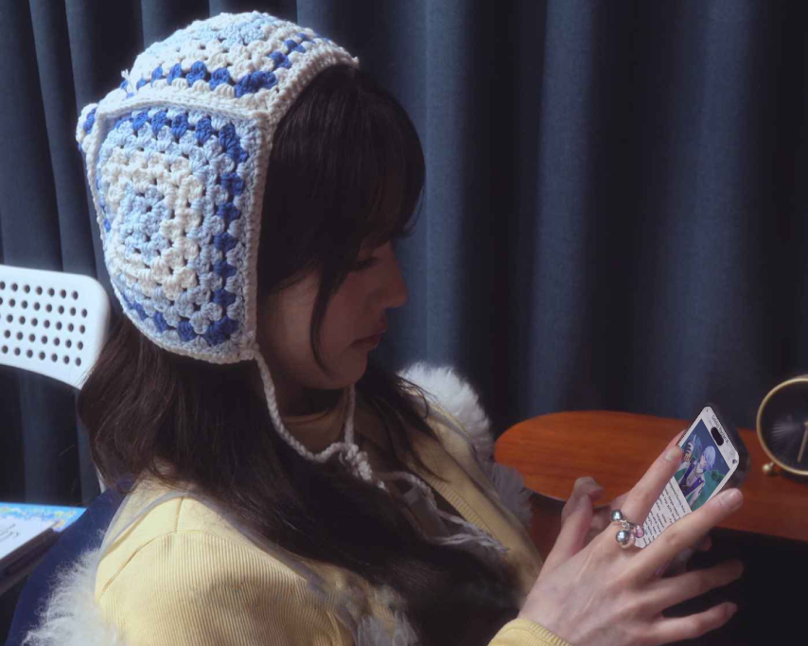

by

**Lydia Gracia (18222035)**

# **A LEAGUE OF MY OWN**

As a STEI student who’s juggling numerous assignments and projects, you often turn to **IVY**, a popular girl group that emerged from the vibrant K-POP scene, for a refreshing break. The six members each have their own unique charm, and watching them never fails to bring a smile to your face.



IVY

You've been hoping to meet them in real life instead of just watching through a flat screen, as you’ve done up until now. And soon, your dream is about to come true! You’ve already secured a ticket to the festival section of the upcoming IVY concert, **‘A LEAGUE OF MY OWN’**.For the first time ever, they’re performing at your university’s hall, Sasana Budaya Ganesha. ITB students even get easier access and discounted tickets ~~(let a girl dream)~~.



Sasana Budaya Ganesha

The concert is still two months away, but you’re already excited every day. Like other die-hard fans, you blast their music daily, practice the fan chants, and plan outfits to impress the girls. You’re going for a school-uniform theme to match **Vicky**, your favorite member who you especially adore.



SDFHSDJAFHDSKAKJSVICKYYYYY

Today is just another day, another night where you plan to stay up late to catch up on deadlines ~~(skill issue)~~. The clock reads 21:58. You decide to take a ‘quick’ break to scroll through X. Actually, you’re just waiting for 22:00, when IVY is set to drop something for their upcoming comeback.

“Today is… M/V teaser. Yosh!”

You check the comeback schedule they posted a week ago. You get ready by loading their YouTube channel on your laptop and their X account on your phone. You also plug in your headphones, ready to blast the snippet at full volume.

“3... 2… 1…”

It’s finally 22:00 sharp. Their X hasn’t posted anything yet, but there’s a strange new video up on their YouTube channel. The title doesn’t seem related to the comeback, but curiosity gets the best of you, and you click on the 0-view video.

“Srrk… Srrk…”

The video looks like leaked CCTV footage from IVY’s production room. The quality is terrible, but it shows the members discussing and working on their music. It seems like behind-the-scenes content while they’re producing this album.

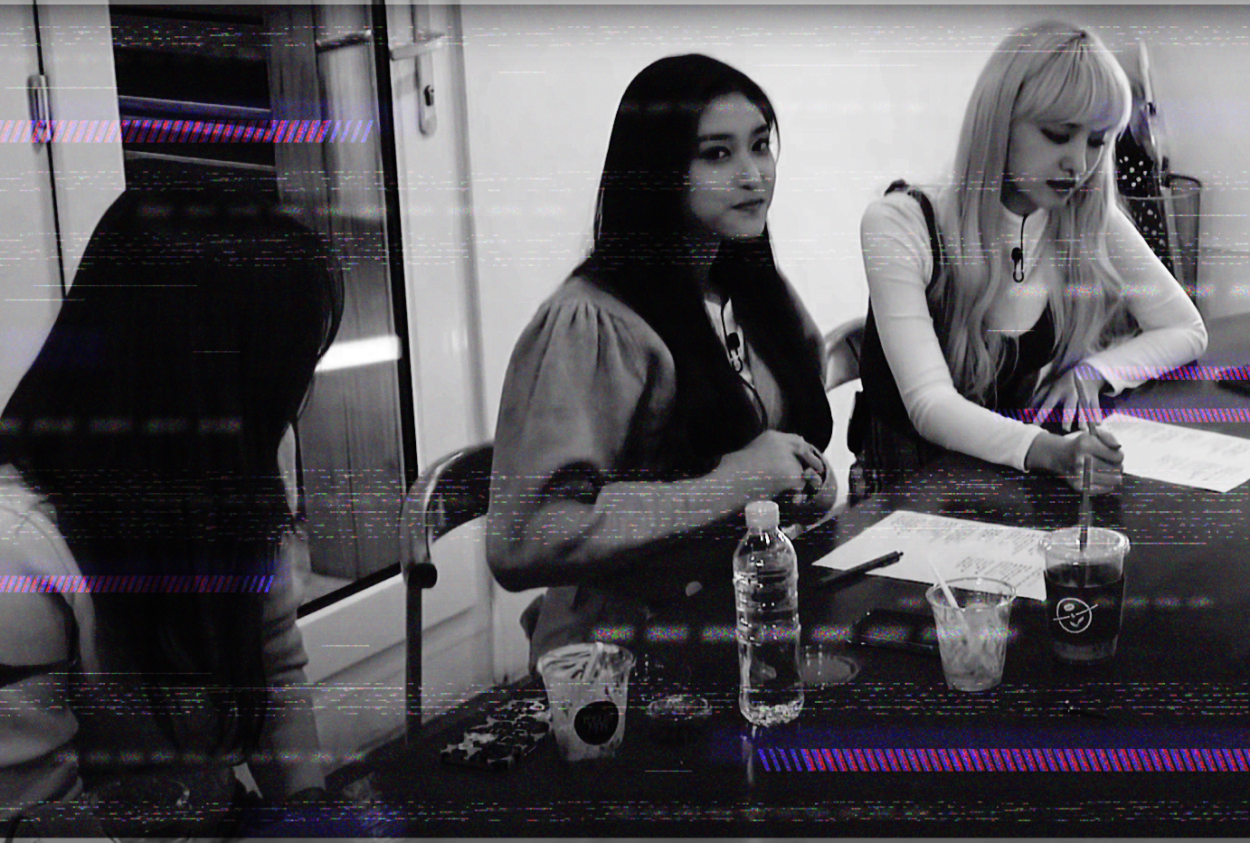

🤡

“What in the world…”

You mutter to yourself. You know this is their first self-produced album, but it’s odd for an M/V teaser to use this concept. It doesn’t match the concept photos they released earlier. You start wondering if there’s a technical issue on their end.

“Siing!”

Suddenly, the video goes completely dark, followed by a long, high-pitched noise that makes your head hurt. Before you can even remove your headphones, your vision blurs and everything goes black as you pass out on your desk.

***

You slowly open your eyes and find yourself in an unfamiliar room. You’re lying on a sofa, and several unfamiliar figures are gathered around a desk across the room, seriously discussing something in hushed tones. The room resembles the CEO’s suite you’ve seen in K-Dramas.

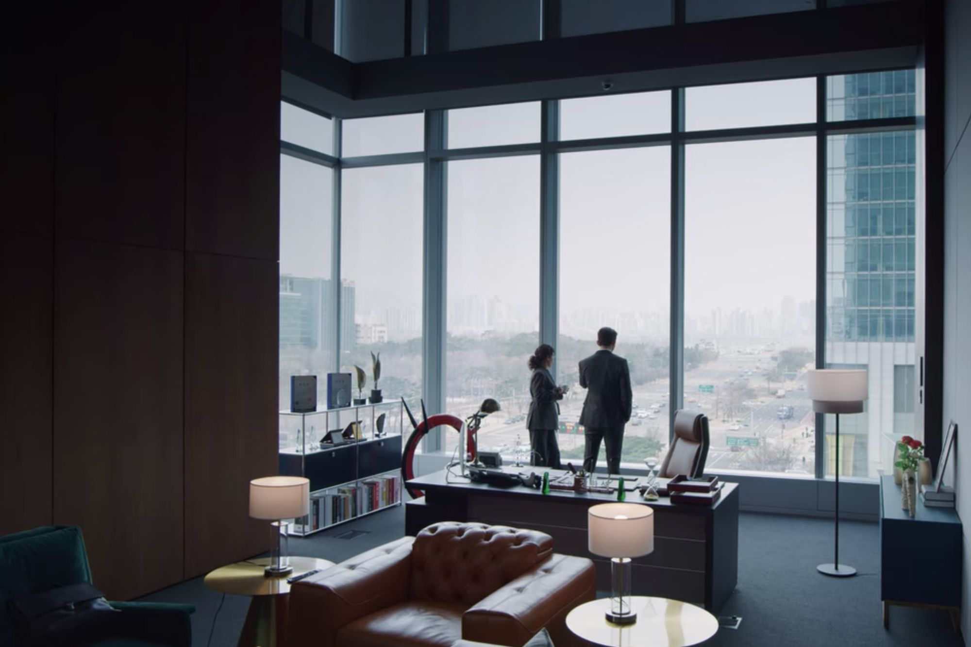

🥶

“W-what.. Where am I?”

“You’ve woken up?”

The figures turn around to face you. To your surprise, some of the faces seem vaguely familiar, though you can’t quite recall where you’ve seen them before. Your head still aches a bit. Before you can gather your thoughts, the unfamiliar person sitting behind the desk starts speaking to you.

He turns out to be the CEO of **SPACESHIP**, the agency that manages IVY. The familiar faces around him are IVY's managers and bodyguards—the ones you've seen in their content. You're still confused and amazed by the fact that you woke up in this room and are casually communicating with these people.

They urgently explain that an unknown entity has been tampering with IVY’s important files. All of IVY’s data has been locked, including their backups. And it’s as if any trace of their existence on the internet has been erased

This mysterious entity sent a strange video to the CEO’s email, warning that they have a limited time before **“*the world’s memory of IVY will be erased forever*”**, which leaves you in shock.

You mention that you clicked on a similar suspicious video on their YouTube channel, but they confirm they never posted anything like that.

“That is strange…”

“I know—it’s hard for me to believe too, but I swear you appeared on that sofa 30 minutes ago right after I read the email. Regardless, I think you’re meant to help us with this challenge. The last sentence in the email… it hinted at your involvement. Please! If you succeed, you’ll get the **chance to meet IVY in person**.”

***

Here you are, sitting in front of one of their PCs in the production room, surrounded by several bodyguards who watch your every move. Thankfully, you have access to the essential resources you need while you’re here. As you examine the files, it becomes clear that you should **manipulate and arrange back various bits in the program**. You ruffle your hair in frustration, knowing you have no choice but to give it your all.



XO, IVY